Lab 08

IT24100308

Dissanayaka M.T.Y.S.K

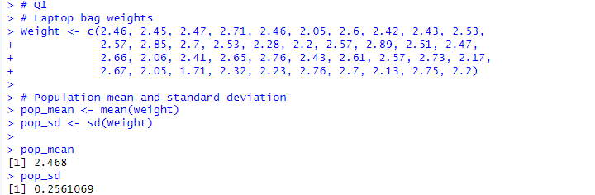1)

2)

3)

